**CREATE A REEL DESIGN USING CANVA**

**INTRODUCTON**

**1.1 Overview**

**Project Objective:** Our primary objective is to develop an engaging and informative social media reel that effectively highlights our harvester business. This project will emphasize our products, services, and the broader impact they have on our target audience.

**Project Scope:** Our harvester business has a story to tell, and this social media reel will be the vehicle for that narrative. Whether it's the cutting-edge technology integrated into our products, their practical applications in agriculture, the numerous benefits they offer, or the unique journey that led to our business's success, this reel will encapsulate it all.

**1.2 Purpose**

In the modern business landscape, harnessing the power of visual storytelling is paramount. Our harvester business has an incredible story to share, and we recognize the immense potential that social media platforms offer to convey that narrative. In today's digital age, video content is king, making it a powerful tool for engaging our audience, building brand recognition, and driving business growth. This project's purpose is to create a captivating social media reel that effectively showcases our harvester business, emphasizing our products, services, and the overall value we bring to our target audience.

**The Role of Visual Storytelling:**

Visual storytelling is more than just a trend; it's a fundamental component of effective communication. It allows us to encapsulate complex messages in a way that's not only easily digestible but also emotionally resonant. The medium of video, in particular, has proven to be incredibly engaging, making it an ideal choice for our project.

**The Role of Visual Storytelling:**

Visual storytelling is more than just a trend; it's a fundamental component of effective communication. It allows us to encapsulate complex messages in a way that's not only easily digestible but also emotionally resonant. The medium of video, in particular, has proven to be incredibly engaging, making it an ideal choice for our project**.**

**2. Problem Definition and Design Thinking**

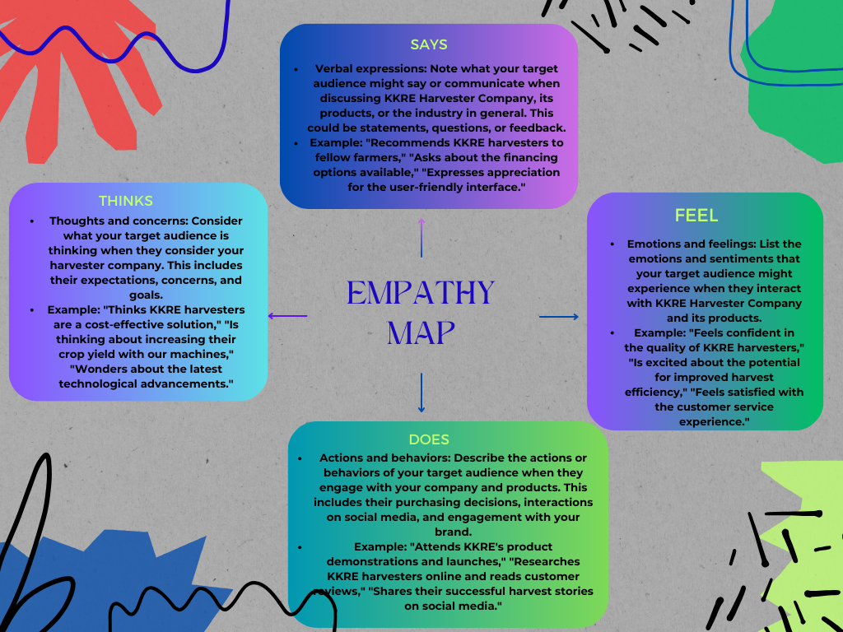 **2.1. Empathy map**

**2.2. Ideation And Brainstorming**

Ideation and brainstorming are creative processes aimed at generating innovative ideas and solutions. In these sessions, a diverse group of individuals collaboratively share and explore ideas without judgment. The primary goal is to unlock creativity and problem-solving potential. By encouraging open dialogue and idea-sharing, ideation and brainstorming can lead to breakthrough concepts, novel strategies, and fresh perspectives. They are essential for tackling challenges, improving processes, and driving innovation in various fields, from business and technology to art and design. The key to successful ideation and brainstorming is to create an environment where all voices are heard, fostering a free flow of ideas, and allowing for the most promising concepts to emerge.

**3. RESULT**

REEL video of KKRE HARVESTER video link-

<https://www.instagram.com/reel/CytUv0qybpr/?igshid=MzRlODBiNWFlZA==>

**Screenshot of my website look in Android or mobile**

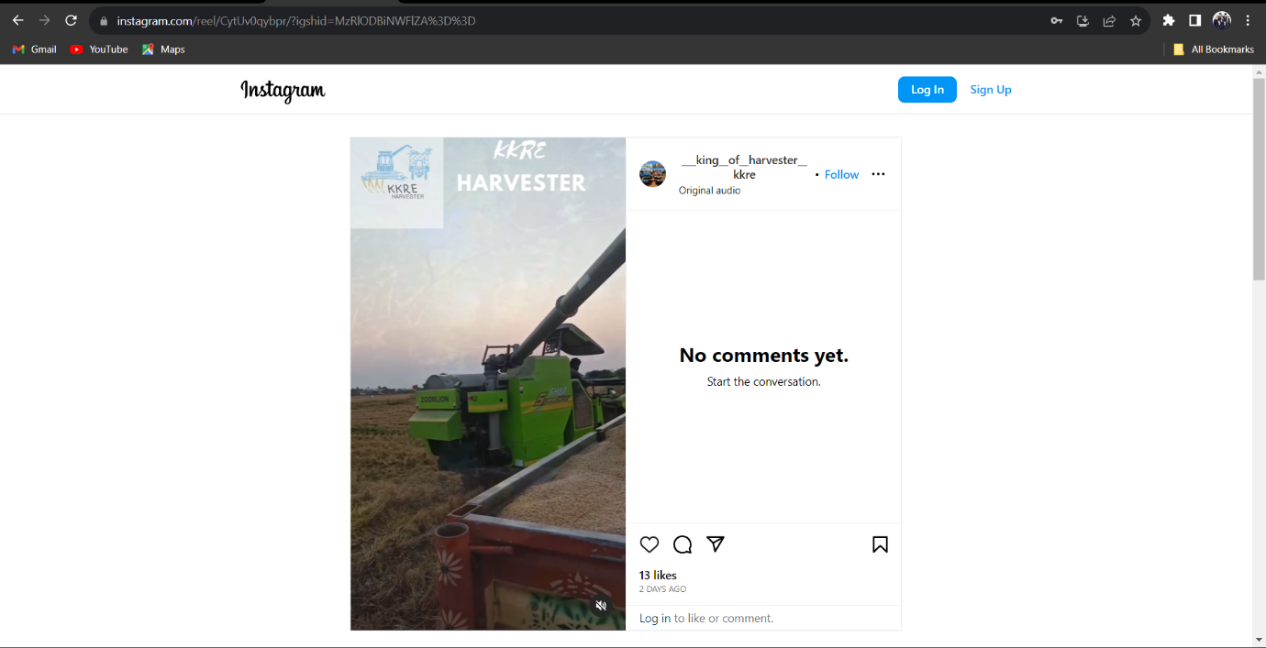

**4. ADANTAGES AND DISADVANTAGES**

4.1 Advantages

1. **Diverse Perspectives:** Ideation and brainstorming sessions involve individuals with diverse backgrounds, experiences, and perspectives. This diversity fosters a rich pool of ideas, as different viewpoints can lead to more comprehensive solutions and novel concepts. It encourages the synthesis of ideas from various disciplines and industries.
2. **Creativity Unleashed:** These processes are designed to unlock creativity. Participants are encouraged to think beyond the obvious and explore unconventional solutions. This environment of free expression can lead to breakthrough ideas that may not emerge in traditional problem-solving settings.
3. **Problem-Solving:** Ideation and brainstorming are powerful tools for addressing complex challenges. By fostering an open and collaborative atmosphere, they help in breaking down intricate problems into manageable components. Teams can collectively identify issues, generate potential solutions, and prioritize actions.
4. **Innovation:** Ideation and brainstorming are at the heart of innovation. They are fundamental for developing new products, services, processes, and technologies. These creative sessions are where initial concepts take form and evolve into groundbreaking innovations. Innovation-driven organizations often make ideation and brainstorming a core practice.
5. **Motivation and Engagement:** Participating in ideation and brainstorming sessions can boost motivation and engagement among team members. The opportunity to contribute, be heard, and see their ideas put into action can be highly motivating. It fosters a sense of ownership and purpose.
6. **Better Decision-Making:** Brainstorming allows for the exploration of various options and perspectives. When followed by a structured evaluation process, it can lead to informed and well-rounded decision-making. This can be particularly valuable in complex business scenarios and strategic planning.
7. **Enhanced Communication Skills:** Engaging in ideation and brainstorming improves communication skills. Participants must articulate their ideas clearly, listen actively to others, and provide constructive feedback. These skills are transferable to other aspects of work and life.
8. **Team Building:** Ideation and brainstorming promote collaboration and team building. Team members work together, build trust, and learn from each other's strengths and experiences. This sense of unity can extend beyond brainstorming sessions, strengthening team dynamics.
9. **Increased Productivity:** By focusing on generating and prioritizing ideas, ideation and brainstorming can lead to more efficient and targeted problem-solving. This can result in increased productivity and a streamlined approach to projects and tasks.
10. **Risk Mitigation:** Brainstorming allows for the exploration of potential risks and challenges. By proactively identifying and addressing these concerns, organizations can better prepare for contingencies and develop strategies to mitigate risks.
11. **Adaptability:** Ideation and brainstorming foster adaptability by encouraging flexible thinking. Participants learn to adapt their strategies and ideas in response to feedback and changing circumstances, a crucial skill in today's rapidly evolving world.
12. **Fostering Employee Engagement:** Engaged employees are more likely to feel invested in their work. Ideation and brainstorming sessions provide a platform for employees to feel connected to the company's goals, fostering a deeper sense of engagement and commitment.
13. **Empowering Leadership:** Ideation and brainstorming are essential tools for leadership development. Leaders who facilitate these sessions effectively can inspire their teams, motivate them to think creatively, and lead by example.
14. **Competitive Advantage:** Organizations that actively encourage ideation and brainstorming gain a competitive edge. By consistently generating innovative solutions and products, they stay ahead in their respective industries.
15. **Continuous Improvement:** Ideation and brainstorming contribute to a culture of continuous improvement. They are invaluable for identifying areas in need of enhancement and working toward optimization in various aspects of business.

**4.2 disadvantages**

1. **Groupthink:** One of the most significant drawbacks of brainstorming is the risk of groupthink, where participants conform to the dominant ideas within the group. This conformity can stifle creativity and result in a lack of diverse perspectives.
2. **Social Pressure:** In a group setting, individuals may feel pressure to conform to social norms and expectations, leading to self-censorship. People might hold back their more unconventional or controversial ideas for fear of judgment or rejection.
3. **Time-Consuming:** Brainstorming sessions can be time-consuming, especially when they lack structure and moderation. Unfocused discussions may lead to prolonged sessions that don't yield meaningful results, potentially hampering productivity.
4. **Lack of Follow-Through:** Ideation sessions often generate numerous ideas, but not all are feasible or practical. Without a clear plan for evaluating and implementing ideas, many concepts might remain unexplored or unrealized.
5. **Dominant Personalities:** Some individuals in a group may have dominant personalities, leading to unequal participation. Those who are more assertive may overshadow quieter team members, hindering balanced idea generation.
6. **Critique and Evaluation Challenges:** In brainstorming, the focus is on generating ideas, not critiquing them. This can be a disadvantage as it defers the evaluation of ideas to a later stage, potentially leading to the pursuit of unworkable concepts.
7. **Overuse of Common Techniques:** Brainstorming sessions often employ common techniques and tools like mind mapping or SWOT analysis. While these methods can be effective, their repetitive use may result in a limited pool of ideas and hinder innovation.
8. **Logistical Challenges:** In today's global and remote work environments, coordinating brainstorming sessions can be challenging. Differences in time zones, language barriers, and the need for virtual tools can hinder effective collaboration.
9. **Failure to Capture All Ideas:** In larger brainstorming sessions, it can be challenging to capture every idea presented. Some valuable contributions might go unnoticed, which can be demotivating for team members.
10. **Resource Intensive:** The resources required for brainstorming sessions, such as facilitators, meeting rooms, or specialized tools, can be costly. This is particularly relevant for organizations with limited budgets.
11. **Lack of Expertise:** Brainstorming often assumes that participants are well-versed in the subject matter. In cases where the participants lack expertise, the quality of ideas generated may be compromised.
12. **Loss of Focus:** Unstructured brainstorming sessions can result in discussions that deviate from the main objective. The lack of a clear agenda and moderation can lead to tangential conversations.
13. **Cultural and Psychological Barriers:** Cross-cultural teams may face communication and understanding barriers during ideation sessions. Differences in communication styles, norms, and values can hinder effective brainstorming.
14. **Idea Overload:** In some cases, an excessive number of ideas are generated, making it challenging to prioritize and work on the most promising concepts. This can lead to analysis paralysis and decision-making difficulties.
15. **Burnout:** Frequent brainstorming sessions can lead to participant burnout. The continuous generation of ideas, particularly in a high-pressure work environment, can be mentally exhausting.

**5. APPLICATIONS**

The Canva reel has multifaceted applications for "KKRE Harvester." Primarily, it serves as a potent marketing tool. It can be shared across various social media platforms to enhance brand visibility, effectively communicating our brand values and product advantages. Moreover, it serves as an educational tool, enabling us to inform our audience about the innovative technologies we employ. Lastly, it's a promotion platform, helping us reach out to potential customers and partners, showcasing our products and their benefits.

**6 . CONCLUSION**

In conclusion, the project to create a Canva reel for "KKRE Harvester" has yielded a dynamic and visually captivating piece of content that encapsulates the essence of our brand. This reel is not just content; it's a bridge, connecting us with our audience, educating them about our innovation, and promoting our products. Our design thinking approach has enabled us to empathize with our target audience, addressing their challenges and aspirations effectively. While there are challenges in the form of time and technical intricacies, the advantages outweigh them by strengthening our brand, engaging our audience, and enhancing brand recognition. The reel finds applications in marketing, education, and promotion, making it a versatile tool for "KKRE Harvester." It is a testament to our commitment to revolutionizing agriculture, one reel at a time, and we are excited to share it with the world.